Figures

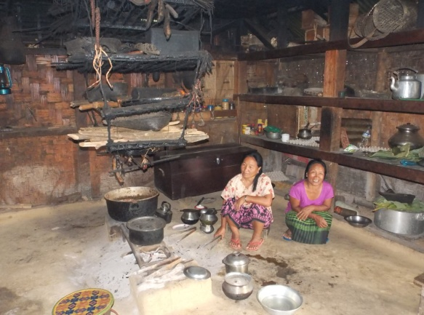  Fig. 1. Typical Naga kitchen showing semi-processed products hanging | 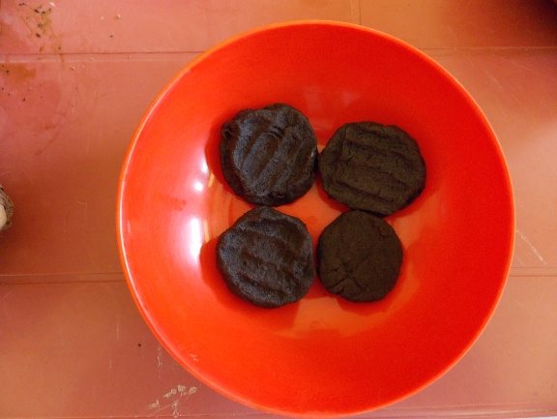  Fig.2. Teangyakwan or Anishi
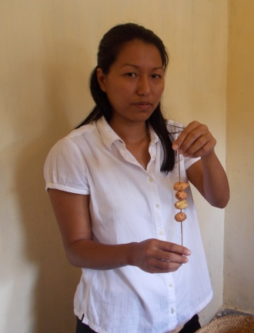  Fig 3. Teangwan | 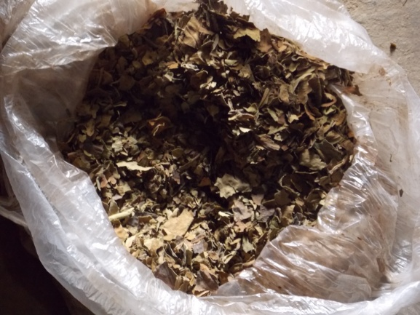  Fig 4. Fluo
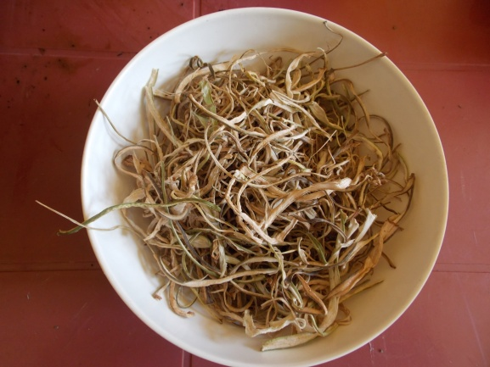  Fig.5. Shouhwan | 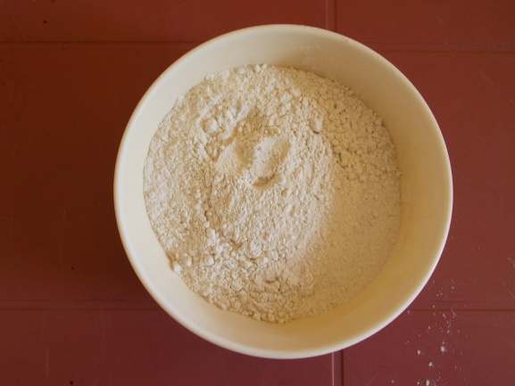  Fig.6. Penkhen Kheh

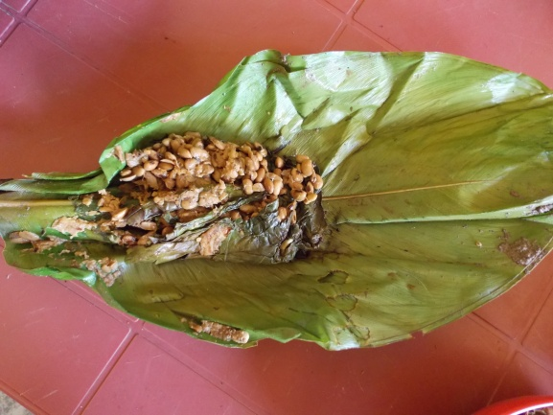  Fig.7. Teangyakhoi | 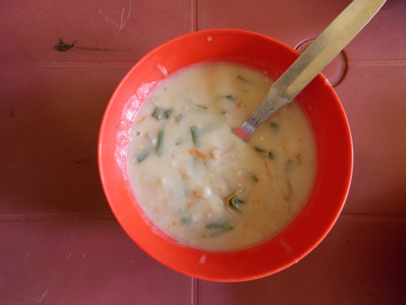  Fig.8. Teanghoi
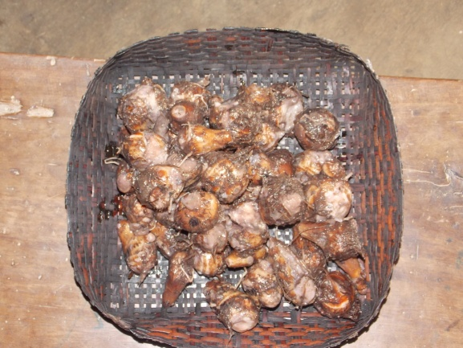  Fig.9. Teang | 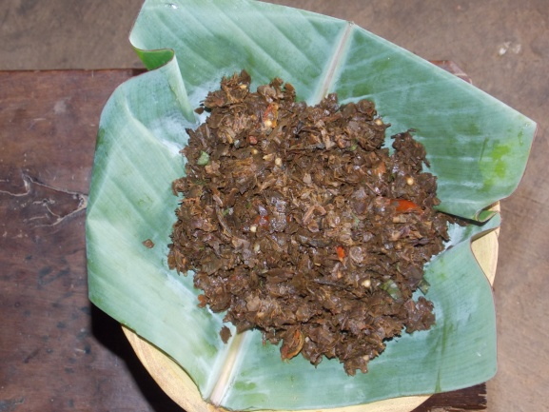  Fig.10. Fluo Curry
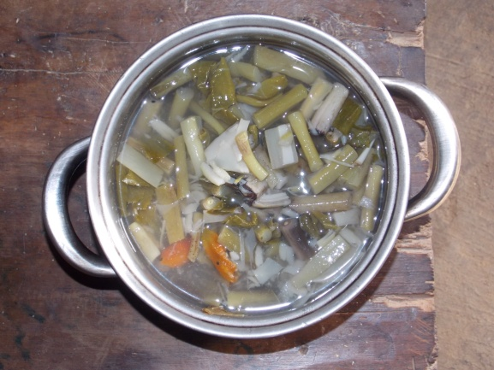  Fig.11. Tung Rahak Sui | 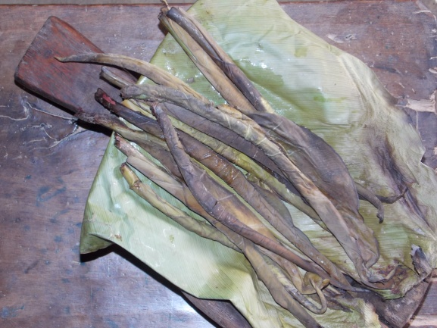  Fig.12. Tungrhak

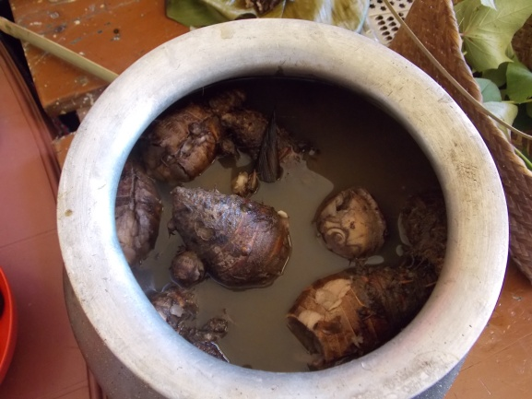  Fig.13. Tunkhon | 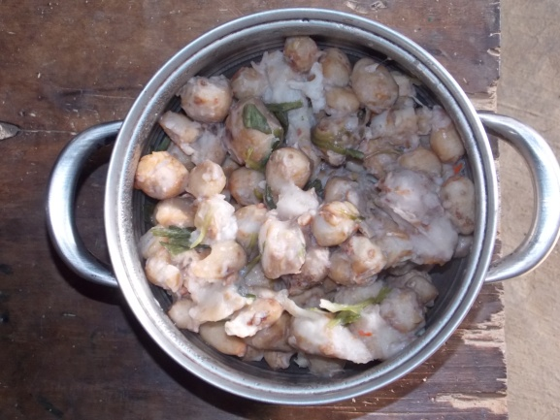  Fig.14. Tung Pai
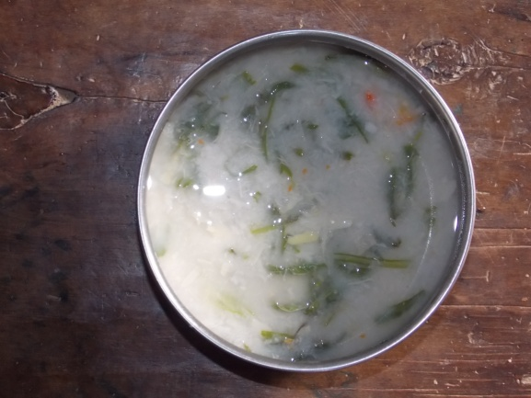  Fig.15. Tungkhai | 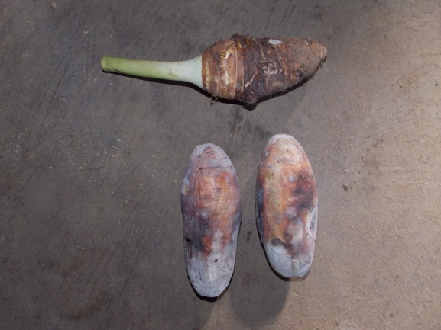  Fig.16. Tunguhok

